1. **Data Scraping**

Data scraping is also referred as Web Scraping. Data Scraping tool helps user to build an automation to extract data from websites in very short amount of time.

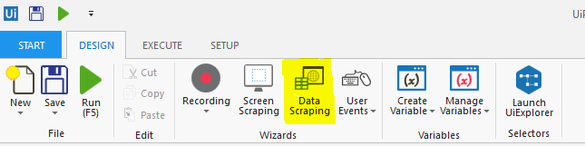



Data scrapping wizard can be found in Design menu or “Extract Structured Data” activity under Screen Scraping.

Case: Get Samsung Mobile name and price from Amazon.com

Steps to scraping data from a website:

1. Goto Amazon.com, search “Samsung Mobile” in search box and hit enter. You can see results having different Samsung mobiles .
2. Now, Click Data Scraping wizard. You will get below Wizard. Click on “Next”.

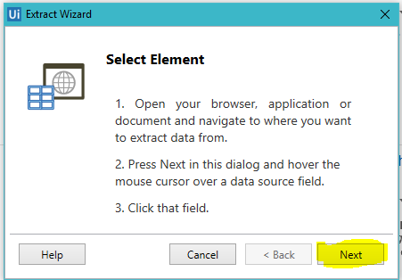

1. Click on first title, it will show like below, again click next and click on title of second mobile.

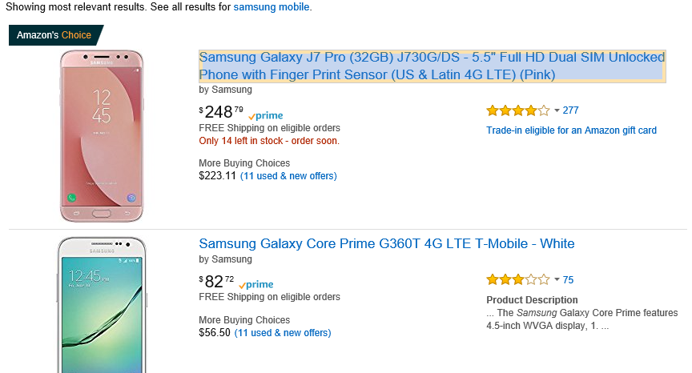

1. Now wizard will show as below: Select the required checkbox here “Extract Text” is selected. So, you will get only title of mobiles. If you want to get URL of given text select Second checkbox “Extract URL”. Rename column Names as our wish, e.g. here you can change “Column 1” to Mobile Name. Now, hit Next Button.

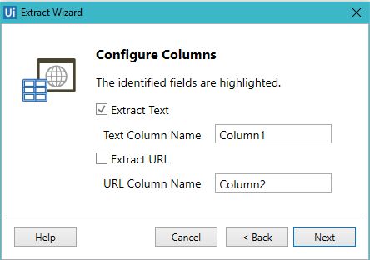

5.You will get below wizard. Here you can see list of name of mobiles present on first page. Here you can see below Maximum number of results box. Put number if you have to scrap fix number of data else put Zero (0) for all.

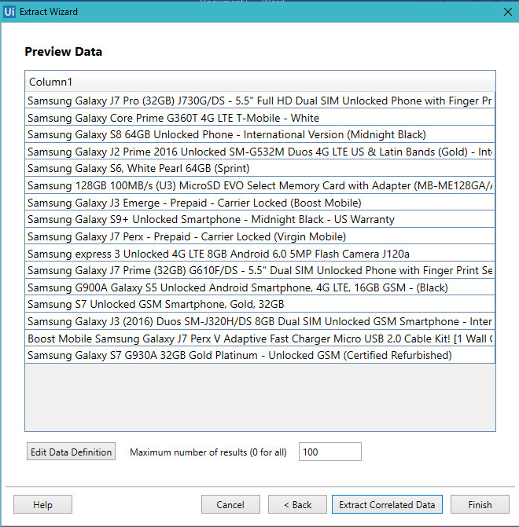

1. To get more details of product such as if you want price then click on “Extract Correlated Data “ shown in above image. Then click on price of mobile. Now wizard will come to select next item as below, click next to select price of second item.

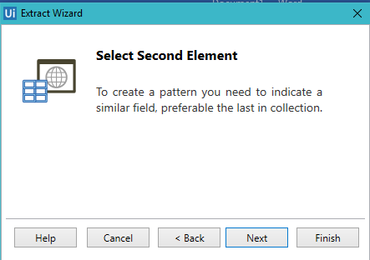

1. Repeat step 4, here you can rename it to Price. Click finish. Now below screen will come. Here in Preview data you can see Mobile name with price.

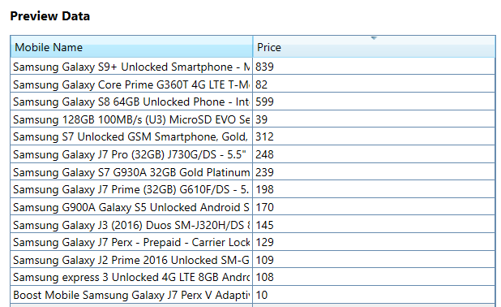

1. Now option will come for multiple pages. If you don’t want to get data from multiple page click on No else click on Yes and indicate on next page link as shown below.

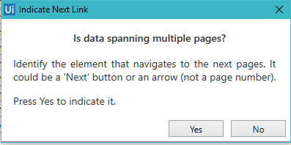

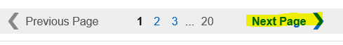

1. Now scraping part has been finished.

We will be returned to UiPath studio.

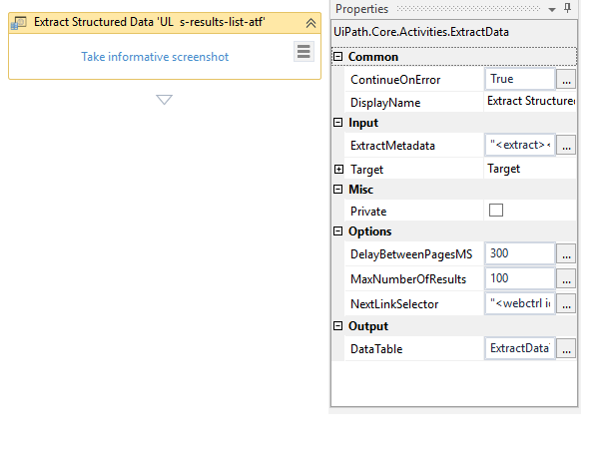

Here you can observe Output. Data type of output is DataTable. It can be used to write in excel using Write Range activity.